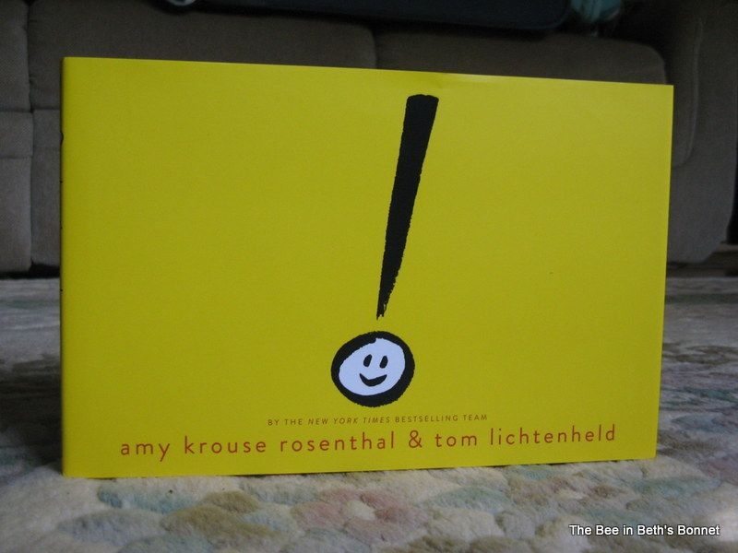

exclamation mark by
Amy Krouse Rosenthal & Tom Lichtenheld

Background: The exclamation mark isn’t quite sure where he fits in in a world full of periods. But after becoming overwhelmed by an inquisitive question mark he finds his true calling.

Design Challenge: It's not easy being seen. Especially when you're not like everyone else. Especially when what sets you apart is YOU. Sometimes we squish ourselves to fit in. We shrink. Twist. Bend. Until -- ! -- a friend shows the way to endless possibilities. Design and build your own exclamation mark.

Criteria: Your exclamation mark must:

- be free - standing
- be at least 8” tall
- reflect your own uniqueness in at least 3 different ways
- have at least one moving part

Materials: You may choose from the following:
cardstock straws construction paper
paper fasteners glue sticks copy paper
12” of tape recycled lids cardboard wheels
buttons pipe cleaners craft sticks

Tools: You may use:

scissors rulers markers or colored pencils
hole puncher Crop-a-dile

